Agenda

*Date: 10/26/13*

*Location: Brody Collaborative Space - Room 1045*

*Actual Time: 1 pm - 2:17 or later*

*Planned Length: 1 hour 17 min or more*

***Silly Picture of the Week:***

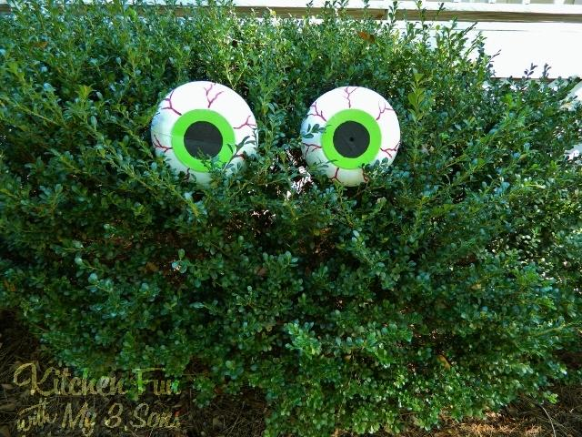

***Please add and comment on anything and everything in the agenda!***

|  |  |  |  |
| --- | --- | --- | --- |
| **Team Member(s)** | **Topic** | **Time** | **Goals** |
| ~~Anyone~~ | ~~Announcements~~ | ~~5 min~~ | ~~If any new developments have occurred the team is updated on them~~ |
| ~~Brian~~ | ~~Team Bonding Update~~ | ~~2 min~~ | ~~If there are any new developments on our eventual team bonding plan update the team~~ |
| ~~John and Brian~~ | ~~Team Budget~~ | ~~5 min~~ | ~~Have we finished and turned that in yet? If not, fill it out real quick and send it off.~~ |
| Andrew F. | Hardware | 20 min | Contact the hardware team and get:   * instructions on how to use the cam. and bracket * info on how consistent getting red eye is * CAD files/ other related documentation   Or schedule a time to get those things |
| ~~Everyone~~ | ~~11/01 Presentation~~ | ~~15 min~~ | ~~Give a quick rundown of what the presentation will be like for those new to TIES; Assign people to write various sections; Assign people to talk about various sections; Assign someone to be responsible for compiling the final product~~ |
| Shumin, David and Mark | Environment Setups | 20 min | Get environment setups done (for those that need it) While others work on subteam work |
| Front End | Cool Stuff | An amazingly short amount of time because everyone is so genius | Awesome results |
| ~~JT and Brian~~ | ~~Crescent Detection~~ | ~~A lot of time~~ | ~~Lay out algorithm; Begin coding (should be pretty dang similar to the code for pupil detection and the code that will be written for tiny white dot detection)~~ |
| Shannon, Shumin and Arvind | TIny White Dot Detection | A lot of time | Lay out algorithm; Begin coding (should be pretty dang similar to the code for pupil detection and the code that will be written for crescent detection) |
| Shannon | Recap and Next steps | 5 min. | Meeting progress/ goal accomplishment is recapped. Next steps are outlined so that every team member goes into next week knowing what they are expected to contribute |

**Time total:** 77 min = 1 hour 17 min or more

# Notes

Archery guy said maybe not at UCSD but maybe at Balboa Park

Make standardized pic folder on github

# Summary

# TODO

* Brian updates us on team bonding progress
* JT and Brian - crescent detection
* Where do we send the finished slides?
* Shannon - Assemble the slides into a finished product and email to the team and to the appropriate ties person
* Mark - figure out python

# Whiteboard Pics

# 

# Useful Links

<http://scrumy.com/DVSFall2013>

Image/Eye Processing in Python Links:

<http://japskua.com/2010/08/05/removing-red-eyes-with-opencv-and-python/>

<http://pythonvision.org/basic-tutorial>